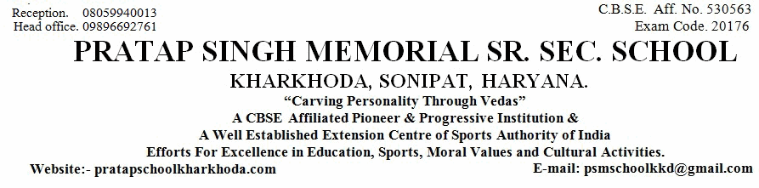
6483
Sr. No.
Admission No.
School Leaving Certificate
4235

1. Name of Pupil
2. Father's Name
Mother's Name
4. Nationality
5. Date of First Admission in the School with Class
6. Date of Birth According to Admission Register (in Figure)
7. Class in Which the Pupil last Studied (in Figure)
8. School/Board Annual Examination last taken with Result
9. Whether Failed, if so mention once/twice in the same class
10. Subjects Studied:
11. Whether qualified for Promotion to the Higher Class
if so, to Which Class (in Figure)
12. Month up to which the (Pupil has Paid) School dues paid
14. Total No. of Working Days
15. Total No. of Working Days Attended
16. Whether NCC Cadet/Boy,Scout/GirlGuide (Details may be Given)
17. Game played or Extra-curricular Activities in which the Pupil usually took part (Mention Achievement Level
19. General Conduct
20. Date of Application for Certificate
20.(a).Date of Issue for Certificate
Religion
ADITYA
RAJEEV KUMAR
REENA
Indian
Hindu
1-Apr-2014
6-Feb-2005
February Sixth Two Thousand Five
(in words)
(in words)
Eighth
PASS
No
Yes
9th
(in words)
Ninth
March, 2018
241
222
No
No
Good
25-Mar-2019
30-Mar-2019
21. Reasons for leaving the School
Parents Desire
23. (a) Student Registration No. (SR
..............................................................................................................................................................
..................................................................
.........................................................
..........................................................................
................................................................
...................................................................................................
.................................................................................
.........................................................................................................................................................................
...............................
.....................................................
....................................................................................
....................................................................................
...........................................................................................
...........................................................
....................................................
.......................................................................................
.......................................................................................................................................
...........................................................................................................................
......................................................................
there in)
................................................................................................................................................................................
..........................
................................
................................
..................................................................................................................................
English
Hindi
Maths
Science
S.St
Sanskrit
iv)
i)
ii)
iii)
v)
vi)
...............................................
3. Whether the student belongs to Schedule Caste or Schedule Tribe
........................................................................
N.A.
13. Any fee concession availed of : if so, the nature of such concession
....................................................................
............................................
............................................
............................................
.......................................
............................................
............................................
No
18. Attended School Upto (During the Current Session)
No
..............................
22. (a). Registration No IX
...........................................................
22. (b). Registration No XI
--------
1517483782
--------
......................................
4th
23(b) Aadhar No.
.....................................................
590232838549
8th
Class Teacher
Checked by
Principal
..............................
..............................................
..................................

