11737
Sr. No.
Admission No.
School Leaving Certificate
5258
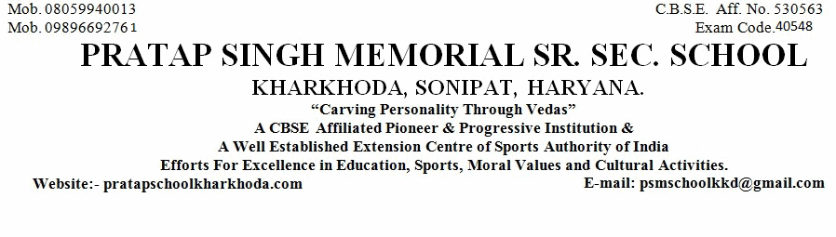
1. Name of Pupil
2. Mother's Name
Father's Name
5. Nationality
6. Date of First Admission in the School with Class
8. Class in Which the Pupil last Studied (in Figure)
9. School/Board Annual Examination last taken with Result
10. Whether Failed, if so mention once/twice in the same class
11. Subjects Studied:
12. Whether qualified for Promotion to the Higher Class
if so, to Which Class (in Figure)
13. Month up to which the (Pupil has Paid) School dues paid
18. Total No. of Working Days
19. Whether NCC Cadet/Boy,Scout/GirlGuide (Details may be Given)
20. Game played or Extra-curricular Activities in which the Pupil usually took part (Mention Achievement Level
15(a). General Conduct
21. Date of Application for Certificate
21(a). Date of Issue of Certificate
Religion
Vidhanshu
Rajesh
Rubi
Indian
Hindu
29-Mar-2020
(in words)
6th
Sixth
PASS
No
Yes
7th
(in words)
Seventh
March, 2021
252
No
31-Mar-2021
1-Apr-2021
22. Reasons for leaving the School
Parents Desire
24. (a) Student Registration No. (SR
..............................................................................................................................................................
..................................................................
.........................................................
..........................................................................
................................................................
...................................................................................................
...............................
.....................................................
....................................................................................
....................................................................................
...........................................................................................
...........................................................
....................................................
.......................................................................................
.......................................................................................................................................
there in)
................................................................................................................................................................................
..........................
.................................
....................................
..................................................................................................................................
English
Hindi
Math
Science
S.St.
Sanskrit
iv)
i)
ii)
iii)
v)
vi)
...............................................
4. Whether the student belongs to Schedule Caste or Schedule Tribe
........................................................................
N.A.
14. Any fee concession availed of : if so, the nature of such concession
....................................................................
............................................
............................................
............................................
.......................................
............................................
............................................
No
23. (a). Registration No IX
...........................................................
23. (b). Registration No XI
--------
1613338190
--------
......................................
6th
24(b) Aadhar No.
.....................................................
306143435771
.................................................................................
3-Dec-2008
3.Date of Birth according to admission Register (IN FIGURE)
December Third Two Thousand Eight
.........................................................................................................................................................................
7.Proof of Date of Birth submitted at the time of admission
..........................................................
15. Attended School Upto (During the Current Session)
31-Mar-2021
...........................
16. Date on which pupil's name was struck of the roll of the school
31-Mar-2021
17. Total No. of Working Days Attended
210
No
........................................................................................................................
......................................................................
SLC/Marksheet/Birth Certificate
Good
Class Teacher
Checked by
Principal
..............................
..............................................
..................................

