11668
Sr. No.
Admission No.
School Leaving Certificate
5466
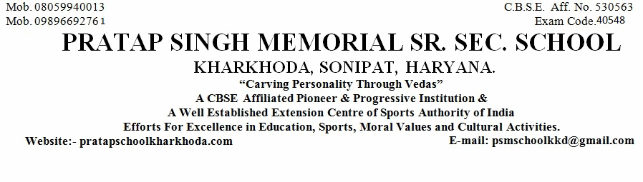
1. Name of Pupil
2. Mother's Name
Father's Name
5. Nationality
6. Date of First Admission in the School with Class
8. Class in Which the Pupil last Studied (in Figure)
9. School/Board Annual Examination last taken with Result
10. Whether Failed, if so mention once/twice in the same class
11. Subjects Studied:
12. Whether qualified for Promotion to the Higher Class
if so, to Which Class (in Figure)
13. Month up to which the (Pupil has Paid) School dues paid
18. Total No. of Working Days
19. Whether NCC Cadet/Boy,Scout/GirlGuide (Details may be Given)
20. Game played or Extra-curricular Activities in which the Pupil usually took part (Mention Achievement Level
15(a). General Conduct
21. Date of Application for Certificate
21(a). Date of Issue of Certificate
Religion
Sahil
Satayender
Murti
Indian
Hindu
29-Jun-2020
(in words)
10th
Tenth
PASS
No
Yes
11th
(in words)
Eleventh
April-2021
-----------
No
25-Aug-2021
25-Aug-2021
22. Reasons for leaving the School
Parents Desire
24. (a) Student Registration No. (SR
..............................................................................................................................................................
..................................................................
.........................................................
..........................................................................
................................................................
...................................................................................................
...............................
.....................................................
....................................................................................
....................................................................................
...........................................................................................
...........................................................
....................................................
.......................................................................................
.......................................................................................................................................
there in)
................................................................................................................................................................................
..........................
.................................
....................................
..................................................................................................................................
English
Hindi
Maths
Science
S.St.
I.T
iv)
i)
ii)
iii)
v)
vi)
...............................................
4. Whether the student belongs to Schedule Caste or Schedule Tribe
........................................................................
N.A.
14. Any fee concession availed of : if so, the nature of such concession
....................................................................
............................................
............................................
............................................
.......................................
............................................
............................................
No
23. (a). Registration No IX
...........................................................
23. (b). Registration No XI
H121401600040
1709362219
--------
......................................
10th
24(b) Aadhar No.
.....................................................
452230934541
.................................................................................
20-Oct-2004
3.Date of Birth according to admission Register (IN FIGURE)
October Twentieth Two Thousand Four
.........................................................................................................................................................................
7.Proof of Date of Birth submitted at the time of admission
..........................................................
15. Attended School Upto (During the Current Session)
No
...........................
16. Date on which pupil's name was struck of the roll of the school
........30-April-2021...................................................................
17. Total No. of Working Days Attended
------------------
No
........................................................................................................................
......................................................................
SLC/Marksheet/Birth Certificate
Good
Class Teacher
Checked by
Principal
..............................
..............................................
..................................

