11564
Sr. No.
Admission No.
School Leaving Certificate
5305
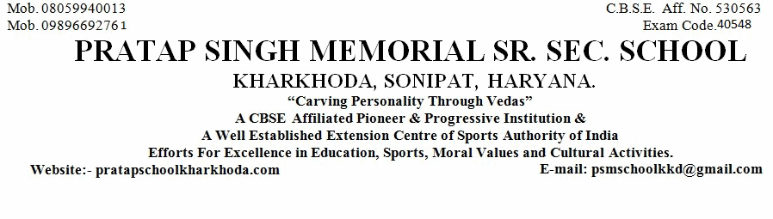
1. Name of Pupil
2. Mother's Name
Father's Name
5. Nationality
6. Date of First Admission in the School with Class
8. Class in Which the Pupil last Studied (in Figure)
9. School/Board Annual Examination last taken with Result
10. Whether Failed, if so mention once/twice in the same class
11. Subjects Studied:
12. Whether qualified for Promotion to the Higher Class
if so, to Which Class (in Figure)
13. Month up to which the (Pupil has Paid) School dues paid
18. Total No. of Working Days
19. Whether NCC Cadet/Boy,Scout/GirlGuide (Details may be Given)
20. Game played or Extra-curricular Activities in which the Pupil usually took part (Mention Achievement Level
15(a). General Conduct
21. Date of Application for Certificate
21(a). Date of Issue of Certificate
Religion
Himanshu
Naresh Kumar
Munesh Devi
Indian
Hindu
2-May-2020 11th
(in words)
11th
Eleventh
PASS
No
Yes
Reading in Class 12th
(in words)
Reading in Class 12th
April, 2021
13
No
24-Apr-2021
24-Apr-2021
22. Reasons for leaving the School
Parents Desire
24. (a) Student Registration No. (SR
..............................................................................................................................................................
..................................................................
.........................................................
..........................................................................
................................................................
...................................................................................................
...............................
.....................................................
....................................................................................
....................................................................................
...........................................................................................
...........................................................
....................................................
.......................................................................................
.......................................................................................................................................
there in)
................................................................................................................................................................................
..........................
.................................
....................................
..................................................................................................................................
English
Hindi
Geography
Political Science
Physical Education
iv)
i)
ii)
iii)
v)
vi)
...............................................
4. Whether the student belongs to Schedule Caste or Schedule Tribe
........................................................................
N.A.
14. Any fee concession availed of : if so, the nature of such concession
....................................................................
............................................
............................................
............................................
.......................................
............................................
............................................
No
23. (a). Registration No IX
...........................................................
23. (b). Registration No XI
--------
1515821665
H222405480280
......................................
24(b) Aadhar No.
.....................................................
751234942492
.................................................................................
24-Mar-2021
3.Date of Birth according to admission Register (IN FIGURE)
March Twenty Fourth Two Thousand Twenty One
.........................................................................................................................................................................
7.Proof of Date of Birth submitted at the time of admission
..........................................................
15. Attended School Upto (During the Current Session)
24-Apr-2021
...........................
16. Date on which pupil's name was struck of the roll of the school
24-Apr-2021
17. Total No. of Working Days Attended
0
No
........................................................................................................................
......................................................................
SLC/Marksheet/Birth Certificate
Good
Class Teacher
Checked by
Principal
..............................
..............................................
..................................

