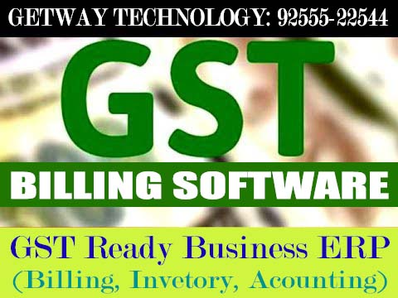
Getway Plus GST Billing ERP Software, So Simple - So Easy. Try Free Demo.
India's No.1 Billing and Accounting Software with Billing, Accounting, Inventory, Stock, POS, SMS, Advance Receipt, Cheque Printing, Customized Bill Format, Barcode Printing etc.
For Free Download below both links and install both file in your system:
Setup File:
https://drive.google.com/file/u/1/d/0BwOTomZdA0MKSi1EVFRyMDdKYlk/view
Support File:
https://drive.google.com/file/d/0BwOTomZdA0MKck5kTDhpczMzb1k/view
GETWAY TECHNOLOGY
GURGAON | M: 9255522544
Email: info@getway.in
www.getway.in | www.getwaygroup.com

